Unit Test using JUnit:

Adding Conversion rate for testing purpose:-

USD to EUR:
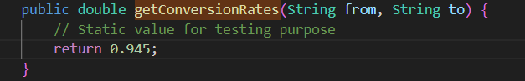

Maven test (mvn test):
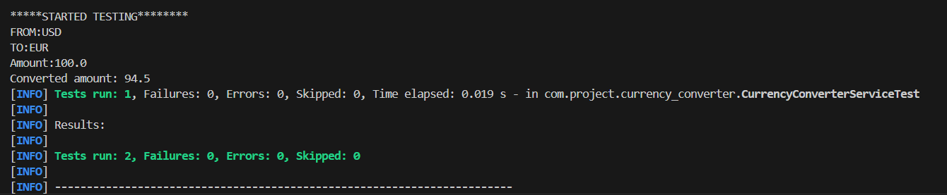

AVAILABLE RATES ( Based on USD)

URL : localhost:8080/api/rates 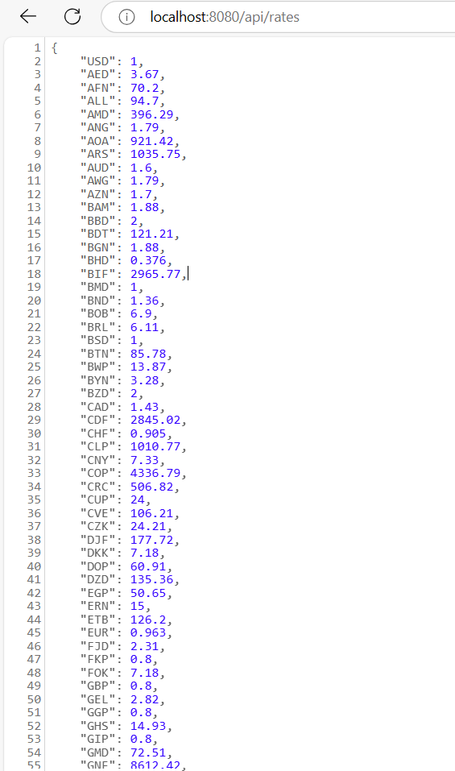

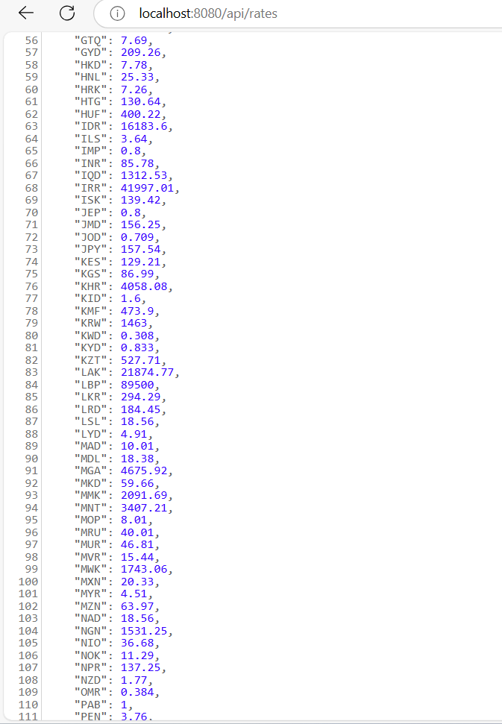

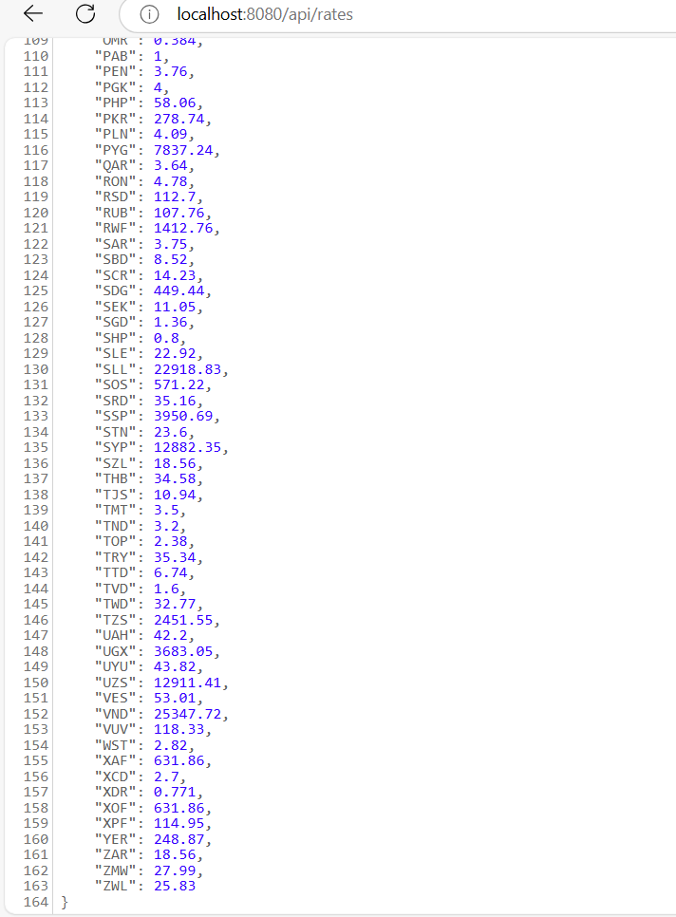

API test cases using POSTMAN:

(mvn spring-boot:run) :-

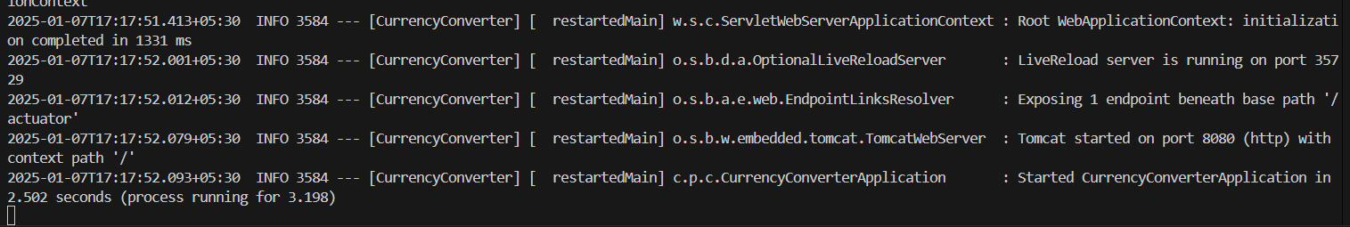
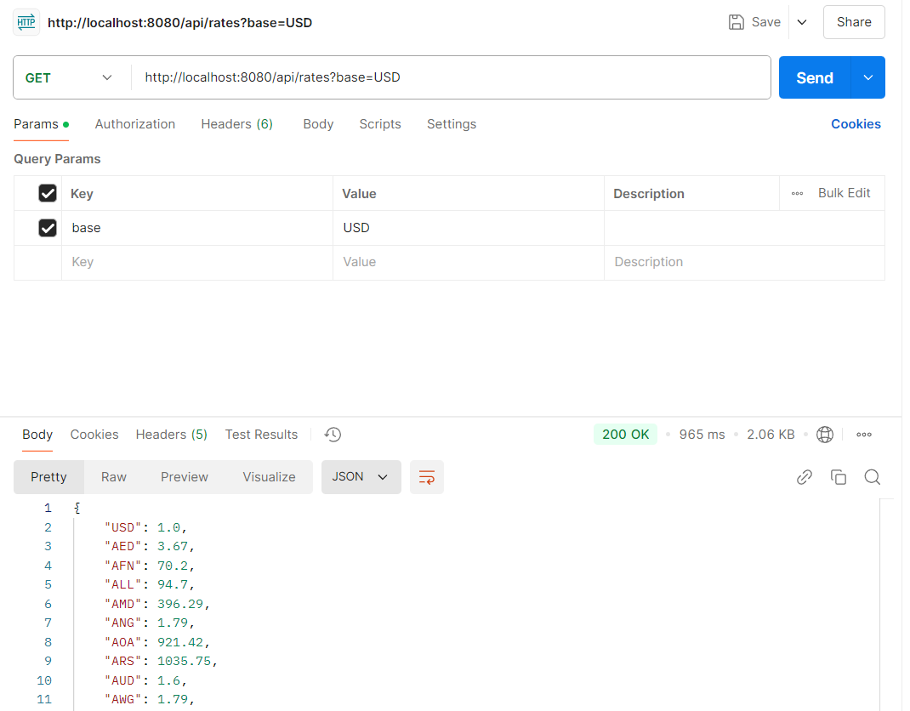

Conversion from USD to EUR

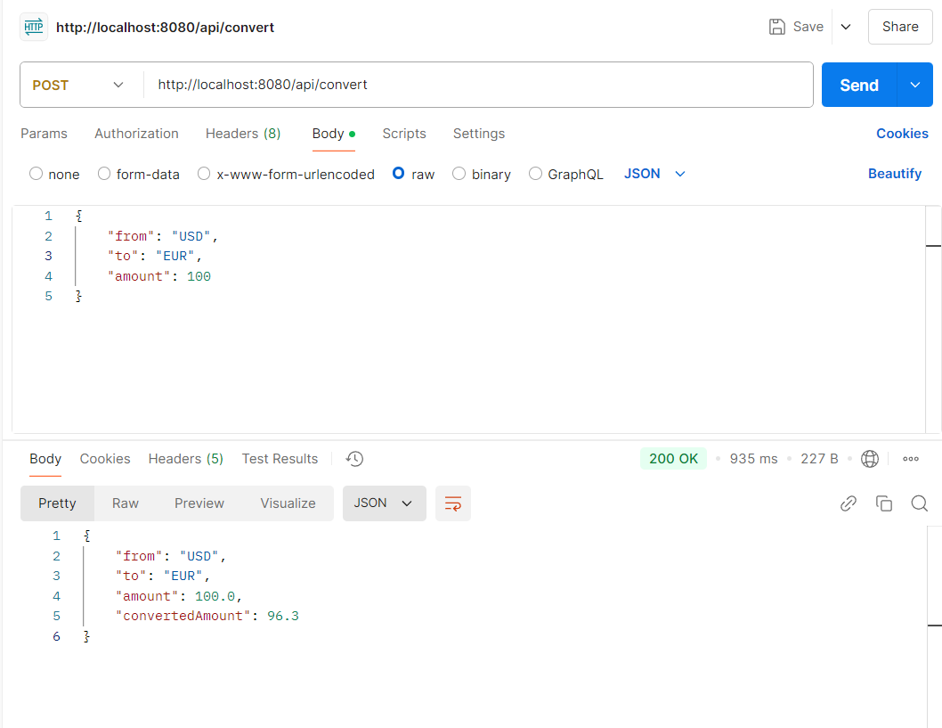

Conversion with INR:
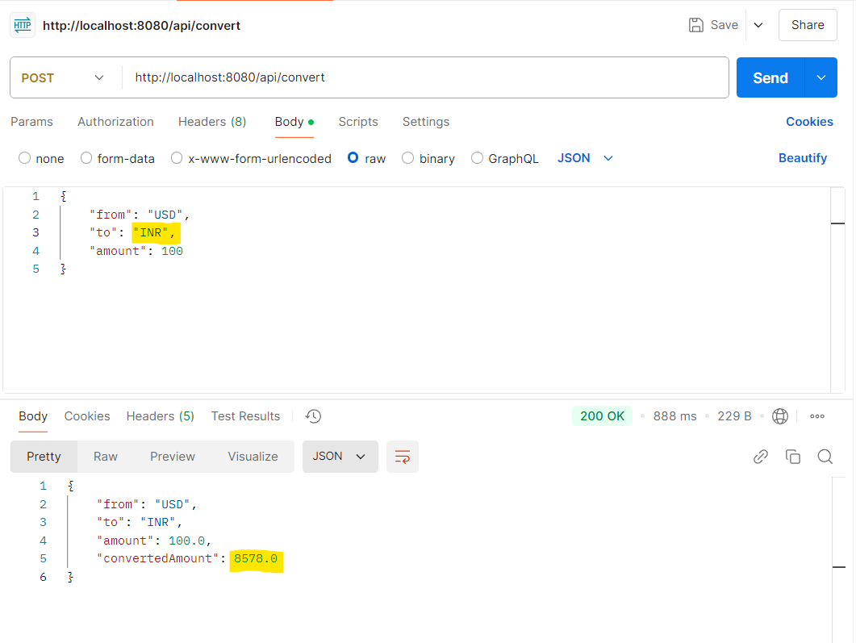
ERROR HANDLING:
- The external API is unavailable: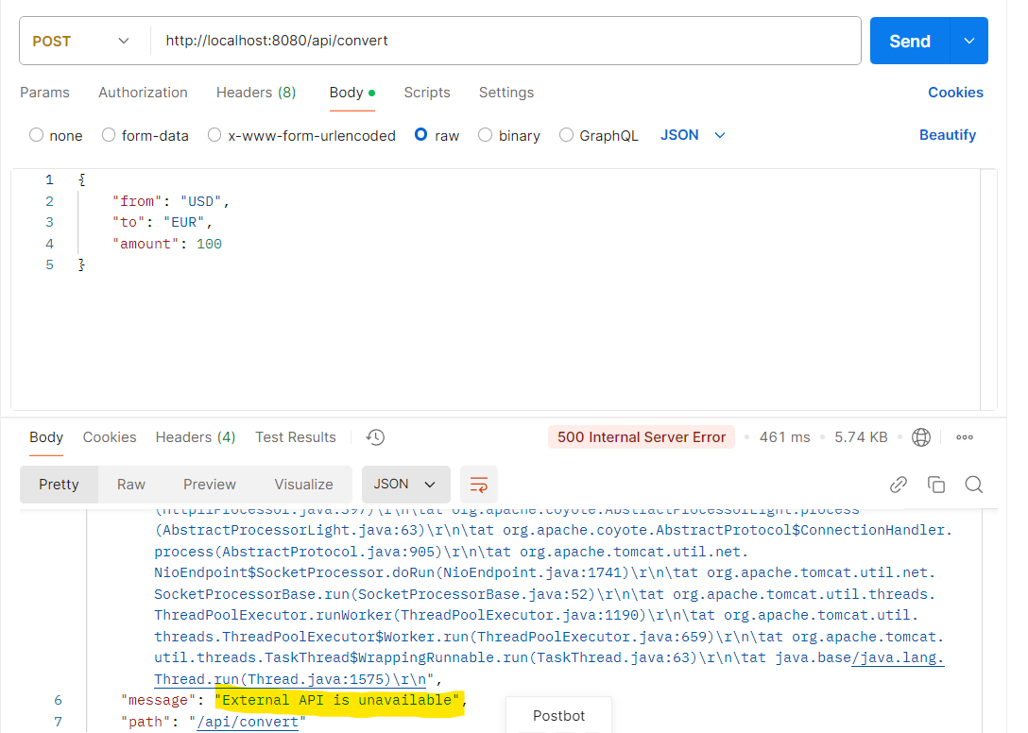

- Invalid currency codes are provided:
